LabMan - Business Case and Draft Plan

# 1.Business Case

## 1.1 Executive Summary

LabMan is a responsive web-based laboratory management system designed to address the challenges faced by the University of Adelaide's laboratory equipment management. The project aims to enhance efficiency, improve user experience, and promote accountability in equipment management. LabMan's core features include streamlined equipment borrowing and returning processes, automated notifications, equipment record query functionality, and cloud-based database deployment. The development team consists of four members.

## 1.2 Project Scope & Goals

1. Develop a user-friendly, responsive web-based laboratory management system
2. Streamline equipment borrowing and returning processes for students and lab managers
3. Automate notifications and reminders for due dates
4. Implement equipment record query functionality for transparent and accountable management
5. Deploy a cloud-based database for easy access across various devices

## 1.3 Motivation

The current paper-based laboratory equipment management system at the University of Adelaide faces several challenges, including inefficiency, long waiting times for students, manual notification processes, and limited access to equipment records. These issues negatively impact user experience and hinder effective equipment management. LabMan seeks to address these challenges by offering a comprehensive, user-friendly solution that will transform the way laboratory equipment is managed at the University of Adelaide.

## 1.4 Benefits of the Project

A. Benefits for Students

1. Improved Efficiency: Streamlined equipment borrowing and returning processes will save time and reduce waiting times.
2. Enhanced User Experience: LabMan's intuitive interface and automated notifications will simplify the equipment management process.

B. Benefits for Lab Managers

1. Increased Accountability: Implementing equipment record query functionality will provide easy access to equipment records, promoting transparency and accountability in equipment management.
2. Time Savings: Automation of notifications and reminders will reduce manual workload and allow lab managers to focus on more important tasks.

C. Benefits for the University

1. Cost Savings: By reducing time spent on manual processes and improving equipment utilization, LabMan will help the University of Adelaide save resources in the long run.
2. Scalability: The responsive web-based design and cloud-based database deployment will enable the system to scale to accommodate the growing needs of the university.

## 1.5 Future Expansions

LabMan's future development will focus on:

1. Integrating with university systems for seamless user authentication and data synchronization.
2. Creating a mobile app for increased accessibility and convenience.
3. Expanding customization options to address unique laboratory needs.

These enhancements will ensure LabMan continues to evolve and adapt to the changing landscape of laboratory equipment management at the University of Adelaide.

## 1.6 Conclusion

In conclusion, LabMan aims to revolutionize laboratory equipment management at the University of Adelaide by addressing the challenges faced by the current paper-based system. The project's motivation lies in the need to improve efficiency, user experience, and accountability in equipment management. The successful implementation of LabMan will bring significant benefits to the university, including cost savings and scalability, resulting in a more effective and user-friendly equipment management system.

# 2. Draft Plan

## 2.1 Introduction

The first iteration of the LabMan project aims to develop the lab-manager end, which includes three key functions: equipment management, return management, request management. This plan outlines our first iteration milestone, schedule, team organization, and communication plan.

## 2.2 Team Organization

### 2.2.1 Roles and Responsibilities

* Chang Liu: Full-stack developer, Test engineer
* Wanxia Yang: Front-end developer, UI & UX designer
* Kaini Chang: Back-end developer, Scrum master
* Shuxiao Peng: Back-end developer, Database administrator

### 2.2.2 Team Dynamics

The team will follow Agile development practices with daily stand-up meetings and weekly team meetings to ensure smooth communication and collaboration. Additionally, the Scrum master(Kaini Chang) will facilitate the Agile process, ensuring the team remains on track and addresses any obstacles that arise.

### 2.2.3 Quality Control

The team will focus on three key aspects of quality control: code quality, functionality, and user experience. Code quality will be maintained through code reviews and version control using GitHub. Functionality will be prioritized by delivering the required features, utilizing the Agile methodology to adapt and iterate as necessary. User experience will be enhanced by gathering feedback from the client and end-users, refining the design, and addressing identified issues.

## 2.3 Iteration 1 Milestone, Activities, and Schedule

Table 1 outlines the activities and projected outputs for the first iteration milestone. The milestone focuses on delivering webpages that support the lab manager in managing borrowing and returning records online.

| **Milestone 1** | **Activities** | **Projected Outputs** |
| --- | --- | --- |
| Define the first milestone to be completed by end of week 7 | List activities required to achieve 1st milestone | Define projected outputs from your work plan |
| Deliver webpages which support the Lab manager managing the borrowing and returning records online. | Sort out requirements of data manipulation | User stories cards/issues on Github project board |
| Designing required tables of relational database | EER model for database |
| designing API for data manipulation | API design; documentation |
| Front-end development of required pages | Equipment management page; Request management page; Return management page. |
| Back-end development—building tables | Built tables with proper fields and relationship; updated EER model |
| Back-end development—API development | Updated API documentation |
| Integration—API testing | Testing cases and report |
| Integration—Debugging | Bug-free system |

Table 1 Tasks Lists for Milestone one

In addition to the milestone table, a Gantt Chart(Figure 1) has been created to visualize the schedule for the first iteration, showing the order of tasks, and dates. The Gantt Chart provides an overview of the planned activities and their durations, facilitating progress monitoring.

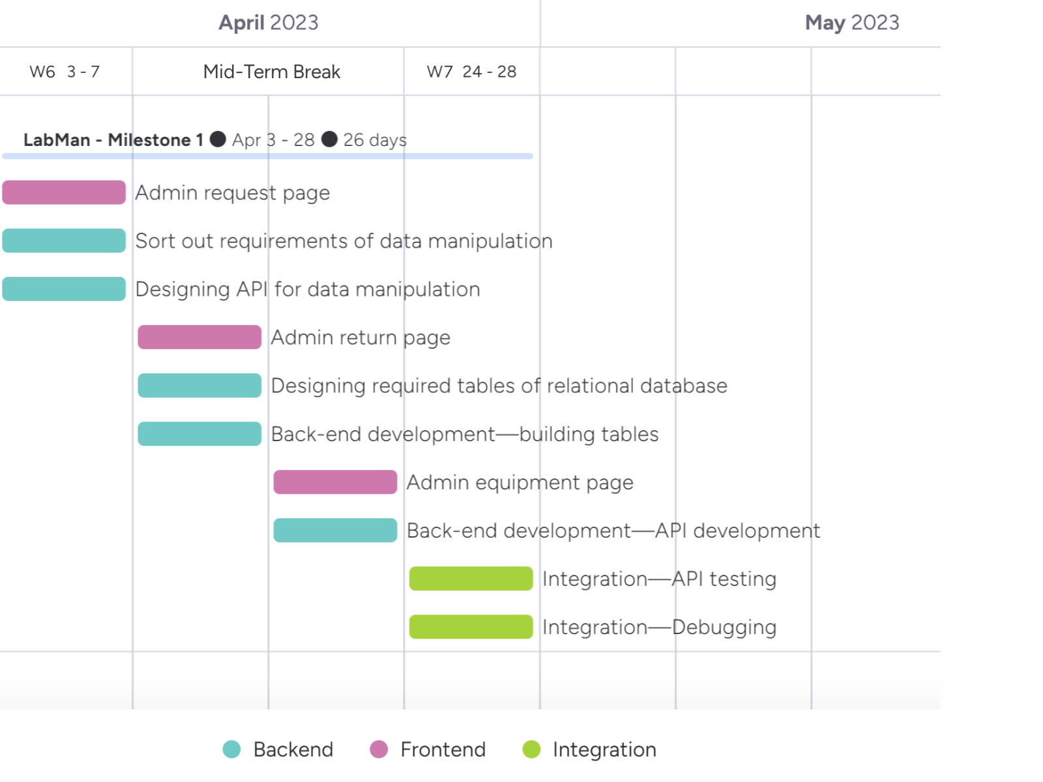

Figure 1 Planning of Milestone 1 Gantt Chart

## 2.4 Communication Plan

The team has established a communication plan to ensure effective communication among team members, course supervisors, tutors, and the client. The plan, detailed in Table 2, includes daily text messages and meetings with team members using Wechat, Discord, and hybrid formats; weekly task management via GitHub and Google Drive; and regular communication with course supervisors, tutors, and clients through email and hybrid meetings. The outlined communication methods facilitate smooth collaboration and timely completion of tasks, supporting the success of the project.

| **Communication with** | **Communication Format** | **Media** | **Frequency** |
| --- | --- | --- | --- |
| Team member | Text message | Wechat,Discord | Daily |
| Meeting | Hybrid: in person, zoom, discord | Daily |
| Task management | Github management tools and Google Drive | Weekly |
| Project document | Github and Google Drive | As needed |
| Project Code | Github team 5 | As needed |
| Course supervisors/Tutor | Meeting confirmation | Email | As needed |
| Meeting | Hybrid: in person, zoom meeting | As needed |
| Project document and code | Github team 5 | As needed |
| Client | Meeting confirmation | Wechat, Email | As needed |
| Meeting | Hybrid: in person, zoom meeting | At least fortnightly |
| Project document | Email | Weekly |

Table 2 Communication Plan

## 2.5 Risk Management

Effectively managing potential risks in the LabMan project involves identifying key risks, assessing their likelihood and severity, and implementing risk management strategies to mitigate their impact. Table 3 presents the risk likelihood matrix, highlighting each risk's description, likelihood, severity, risk indicator, and management strategies. By implementing these risk management strategies, we aim to mitigate the potential negative impacts of these risks on the project and ensure its successful completion.

| **Risk name** | **Description** | **Likelihood** | **Severity** | **Risk Indicator** | **Risk management Strategies** |
| --- | --- | --- | --- | --- | --- |
| **Scope creep** | Continual expansion of project scope beyond initial requirement | Medium | Medium | Yellow | Establish clear project requirement from beginning, build change control process and communicate with stakeholder if change |
| **Poor Human resource** | Absence since sickness and personal affairs | Low | High | Red | Cross skill training, get flu vaccination for all the team members |
| **Bad quality assurance** | Inadequate testing and quality assurance process | High | High | Red | Develop and implement a testing plan, perform the regular code reviews, and use automate testing tools where possible |

Table 3 Risk Management

## 2.6 Conclusion

By the end of the first iteration, the team aims to complete the main part of the lab-manager end, including equipment management, return management, request management functionalities. The team will collaborate closely, follow the outlined schedule, and maintain effective communication throughout the project.